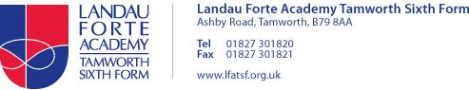**Personalised Learning Checklist**

Subject: Travel and Tourism

Year group: Year 12

Dear Student,

During the academy closure you have been set a number of tasks. The list below is the learning you should have completed. Your teacher will use the list to check your progress during this time. It may be used for short quizzes, mini assessments or homework. Where there are gaps your lessons will focus on improving your knowledge and understanding.

|  |  |  |  |  |
| --- | --- | --- | --- | --- |
| Objective | My personal RAG rating (Red- do not understand, Amber- some understanding, Green- I am confident | | | Teacher RAG rating |
| Unit 9 – Assignment 1   |  | | --- | |  |   Investigate the nature, role and appeal  of visitor attraction | RED | AMBER | GREEN |  |
| Unit 9 – Assignment 2  Examine how visitor attractions meet  the diverse expectations of visitor | RED | AMBER | GREEN |  |
| Unit 9 – Assignment 3  Explore how visitor attractions respond  to competition and measure their success and appeal | RED | AMBER | GREEN |  |