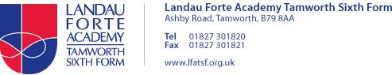**Personalised Learning Checklist**

Subject: Criminology

Year group: 12 (covered between March and June – remote learning)

Dear Student,

During the academy closure you have been set a number of tasks. The list below is the learning you should have completed. Your teacher will use the list to check your progress during this time. It may be used for short quizzes, mini assessments or homework. Where there are gaps your lessons will focus on improving your knowledge and understanding.

|  |  |  |  |  |  |
| --- | --- | --- | --- | --- | --- |
| Objective | | My personal RAG rating (Red- do not understand, Amber- some understanding, Green- I am confident | | | Teacher RAG rating |
| Unit 2: AC4.1  The learner can assess the use of criminological theories in informing policy development. | | RED | AMBER | GREEN |  |
| AC4.2  The learner can explain how social changes affect policy development. | | RED | AMBER | GREEN |  |
| AC4.3  The learner can discuss how campaigns affect policy making. | | RED | AMBER | GREEN |  |
| Criminology Media Project PREP | | RED | AMBER | GREEN |  |
| Unit 3: AC1.1  The learner can evaluate the effectiveness of the roles of personnel involved in criminal investigations. | | RED | AMBER | GREEN |  |
| AC1.2  The learner can assess the usefulness of investigative techniques in criminal investigations. | | RED | AMBER | GREEN |  |
| AC1.3  The learner can explain how evidence is processed. | | RED | AMBER | GREEN |  |
|  |